1. The climate zones for marsh soil storage and soil rate from this paper were inconsistent (temperate warm *vs* subtropical for the same site).

Blanca’s response can be found below.

2. The soil C pool data was from Table 1. Meng was not able to repeat the calculation, see Blanca’s response below. The calculation was repeated in the SAS code.

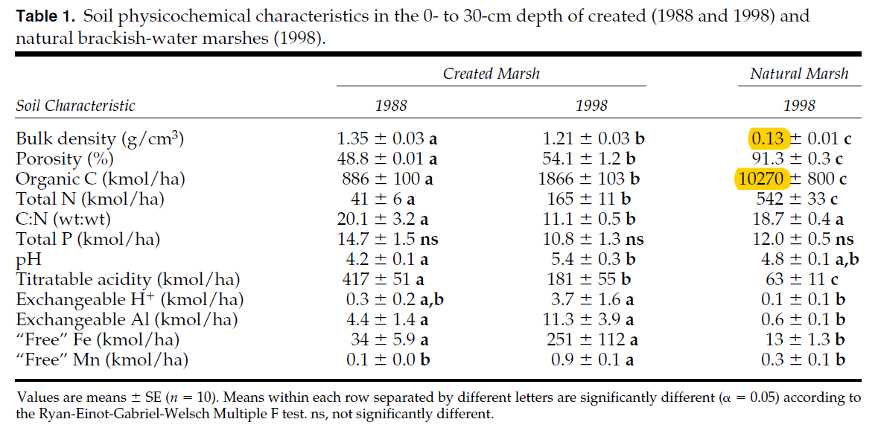

*[Blanca’s Response] very tricky. this was in the dataset they gave me already. use the organic C kmol/ha of natural and created 1998 numbers doing this conversion:*

*10270 kmol = 10270\*10^3 mol;*

*1ha = 10^4 m2*

*30 cm = 0.3 m*

*(10270\*10^3)/(0.3\*10^4) = 3423 mol C/m3*

*1 mol C = 12 g C*

*1 m3 = 10^6 cm3 (cm3 = cc)*

*3423\*12/10^6 = 0.04108 gC/cc*

*do the same for the other one.*

3. The soil C rate data was from Table 2.

